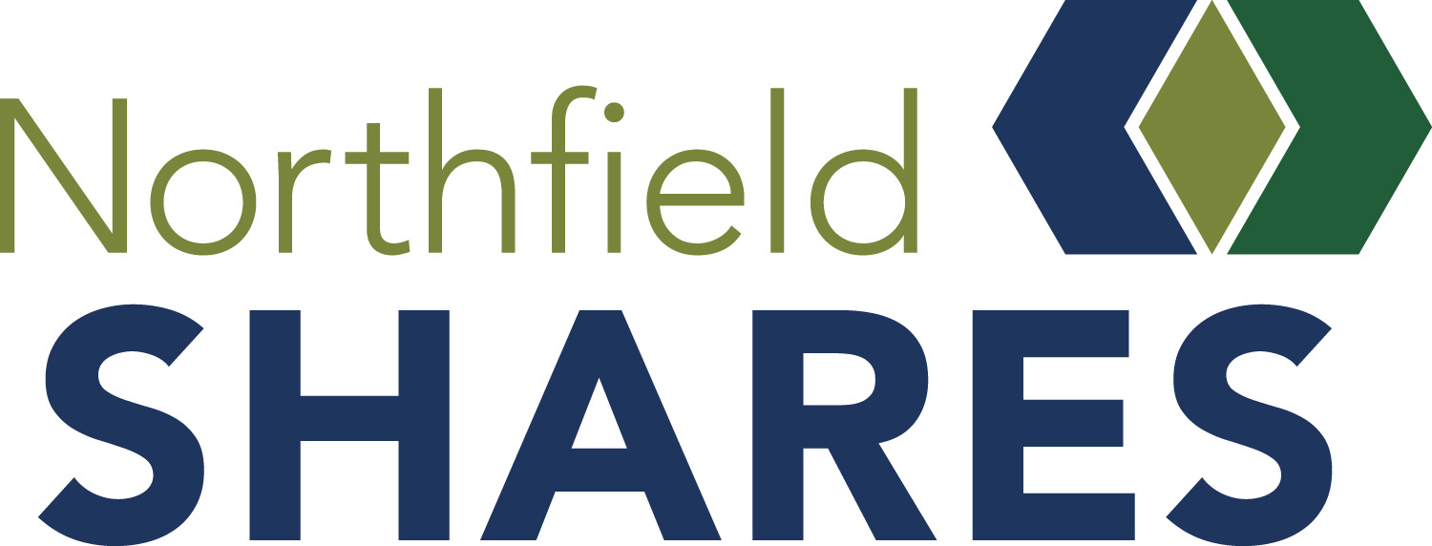

GRANT IMPACT REPORT

Please tell us about your successes and your setbacks up to this point. We applaud your efforts and look forward to hearing how you have supported and will be supporting the Northfield community. This report is invaluable as we celebrate not only the work you do, but also share with our stakeholders and donors the impact their gifts to Northfield Shares are making in our community. Please send this completed report and photos of your project/program by October 4 to info@northfieldshares.org. If you are intending to apply for a current grant, this form must be completed by October 4 to be considered for a 2021-22 grant.

Grant Award Year Click or tap here to enter text.
Organization Click or tap here to enter text.
Contact Person Click or tap here to enter text.
Phone Click or tap here to enter text. Cell Phone Click or tap here to enter text. Email Click or tap here to enter text.

Project Title Click or tap here to enter text.
Start Date: Click or tap here to enter text. End Date: Click or tap here to enter text.
Total Budget for Project: Click or tap here to enter text.

FUNDING

Amount Requested from Northfield Shares: Click or tap here to enter text.

Amount Granted from Northfield Shares: Click or tap here to enter text.

Please summarize the intended use of grant funds (<200 words): Click or tap here to enter text.

What was the actual use of grant funds? Explain any differences. (<200 words) Click or tap here to enter text.

Did this grant from Northfield Shares help leverage more funds for your project? If yes, how much
and from what other sources? Click or tap here to enter text.

Continue

GOAL AND OUTCOMES

Goals | Progress Toward Goals | Assessment and Measures (please include # of people/audiences impacted)
- Click or tap here to enter text. | Click or tap here to enter text. | Click or tap here to enter text.
- Click or tap here to enter text. | Click or tap here to enter text. | Click or tap here to enter text.
- Click or tap here to enter text. | Click or tap here to enter text. | Click or tap here to enter text.
- Click or tap here to enter text. | Click or tap here to enter text. | Click or tap here to enter text.

If the project is continuing, what are the next steps? How would you improve or change your process? (200-300 words)
Click or tap here to enter text.

How did/will the community of Northfield benefit from this project? (<200 words)
Click or tap here to enter text.
How did your project engage volunteers or other organizations? (<200 words)
Click or tap here to enter text.

How did you recognize Northfield Shares’ funding of your project? (<200 words)
Click or tap here to enter text.
What else would you like to add about your Northfield Shares-funded project?
Click or tap here to enter text.

Supplemental Materials:
You may request a Microsoft Word document if necessary. Supplemental Materials such as photos of activities/people related to this grant or products like news stories, testimonials/feedback from beneficiaries or other items are requested and encouraged to help demonstrate the impact of your grant.

Thank you from Northfield Shares!
Northfield Shares P.O. Box 802, Northfield, MN 55057 (507)403-9755
www.northfieldshares.org email info@northfieldshares.org

