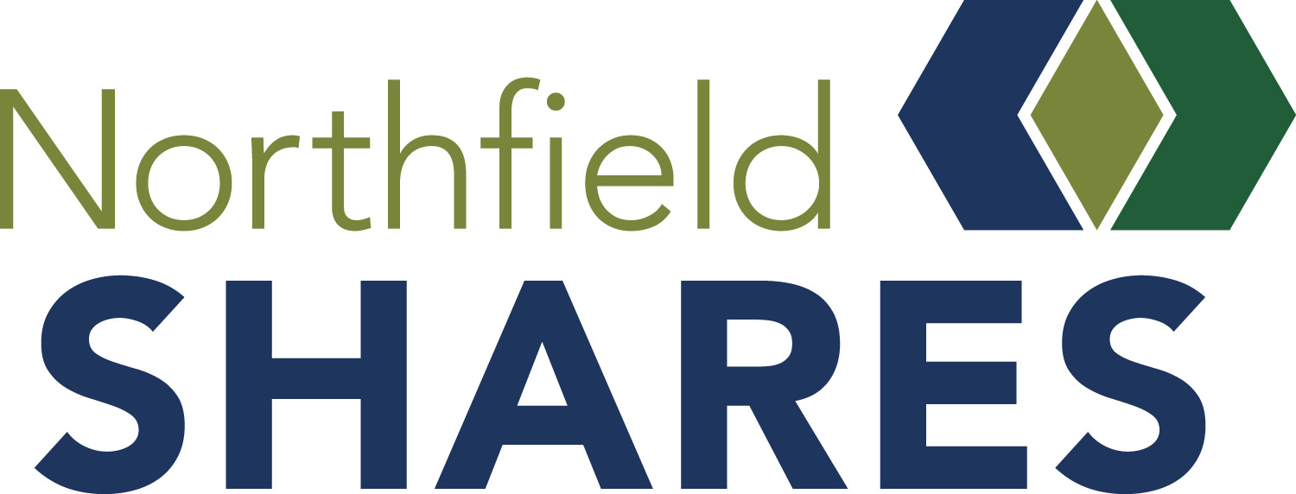

GRANT IMPACT REPORT

Please tell us about your successes and your setbacks up to this point. We applaud your efforts and look forward to hearing how you have supported and will be supporting the Northfield community. Please send this completed report and photos of your project by September 30 to info@northfieldshares.org.

Grant Award Year ____________ ___ ______
Organization ______
Contact Person ______
______
Phone Cell Phone Email

Project Title ______
Start Date: ___ End Date: ____ _____________
Total Budget for Project: _____________

FUNDING

Amount Requested from Northfield Shares: ______
Amount Granted from Northfield Shares: ______
Please summarize your intended use of grant funds: ____________________________________________
______
______
______

What was your actual use of grant funds? Explain any differences. ________________________________
______
______
______
_______________________________________________________________________________________________

Did this grant from Northfield Shares help leverage more funds for your project? If Yes, how much
and from what other sources?________________________________________________________________
______
________________________________
_______________________________________________________________________________________________
_______________________________________________________________________________________________

GOAL AND OUTCOMES

Goals | Progress Toward Goals | Assessment and Measures (please include # of people/audiences impacted)
1.
2.
3.
4.

If you continue your project, what are the next steps? How would you improve or change your

process? _____________

______

______

How did/will the community of Northfield benefit from this project? ______

______

______

How did your project engage volunteers or other organizations? _________________________________

______

______

How did you recognize Northfield Shares’ funding of your project? _____________

______

What else would you like to add about your Northfield Shares-funded project?

_____ _

Supplemental Materials:
You may request a Microsoft Word document if necessary. Supplemental Materials such as photos of activities/people related to this grant or products like news stories, testimonials/feedback from beneficiaries or other items are greatly appreciated to help demonstrate the impact of your grant.

Thank you from Northfield Shares!
Northfield Shares P.O. Box 802, Northfield, MN 55057 (507)403-9755
www.northfieldshares.org email info@northfieldshares.org

