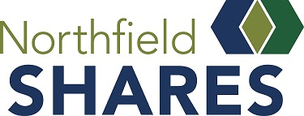

Grant Applicant Frequently Asked Questions

Is my organization eligible for a grant?
• Grantee organization must be designated as a 501(c)3, or be fiscally sponsored by a 501(c)3
• Grantee organizations must serve people within the geography of the Northfield School District

What will NOT be funded by a Northfield Shares grant?
Requests will NOT be considered from:
• Religious organizations whose proposals support theological functions
• Political campaigns/candidates or political parties
- Labor or fraternal groups
• Projects that discriminate (e.g., race, color, national origin, sex, religion, ability, sexual orientation, and gender identity)

Funding will NOT be provided for the following:
- Funding that solely benefits an individual or individual family
- Expenditures incurred by the grantee prior to receiving the Stronger Together Fund grant
- Basic municipal services
- Purchasing real estate
- Endowment campaigns
- Capital campaigns
- Previously incurred debt
- Sectarian religious programs
- Lobbying

- For-profit organizations
- Fundraisers
- Entry Fees/Pledges/Scholarships

What grant request amounts will be considered?
Minimum grant requests should be $200, and the maximum award is $25,000

When are applications due?
Proposals are due October 5, 2020. Decisions made finalized in November. Funds to be distributed by end of calendar year.
Where do I send the completed application?
Email to: info@northfieldshares.org or Mail to: PO Box 802, Northfield MN 55057

For more Information contact:
Carrie Carroll at Northfield Shares carriecarroll@northfieldshares.org 507-403-9755

